Project Design Phase-II
Data Flow Diagram & User Stories

Date | 31 January 2025
Team ID | LTVIP2026TMIDS41887
Project Name | visualization tool for electric vehicle charge and range analysis
Maximum Marks | 4 Marks

Data Flow Diagrams:
A Data Flow Diagram (DFD) is a traditional visual representation of the information flows within a system. A neat and clear DFD can depict the right amount of the system requirement graphically. It shows how data enters and leaves the system, what changes the information, and where data is stored.

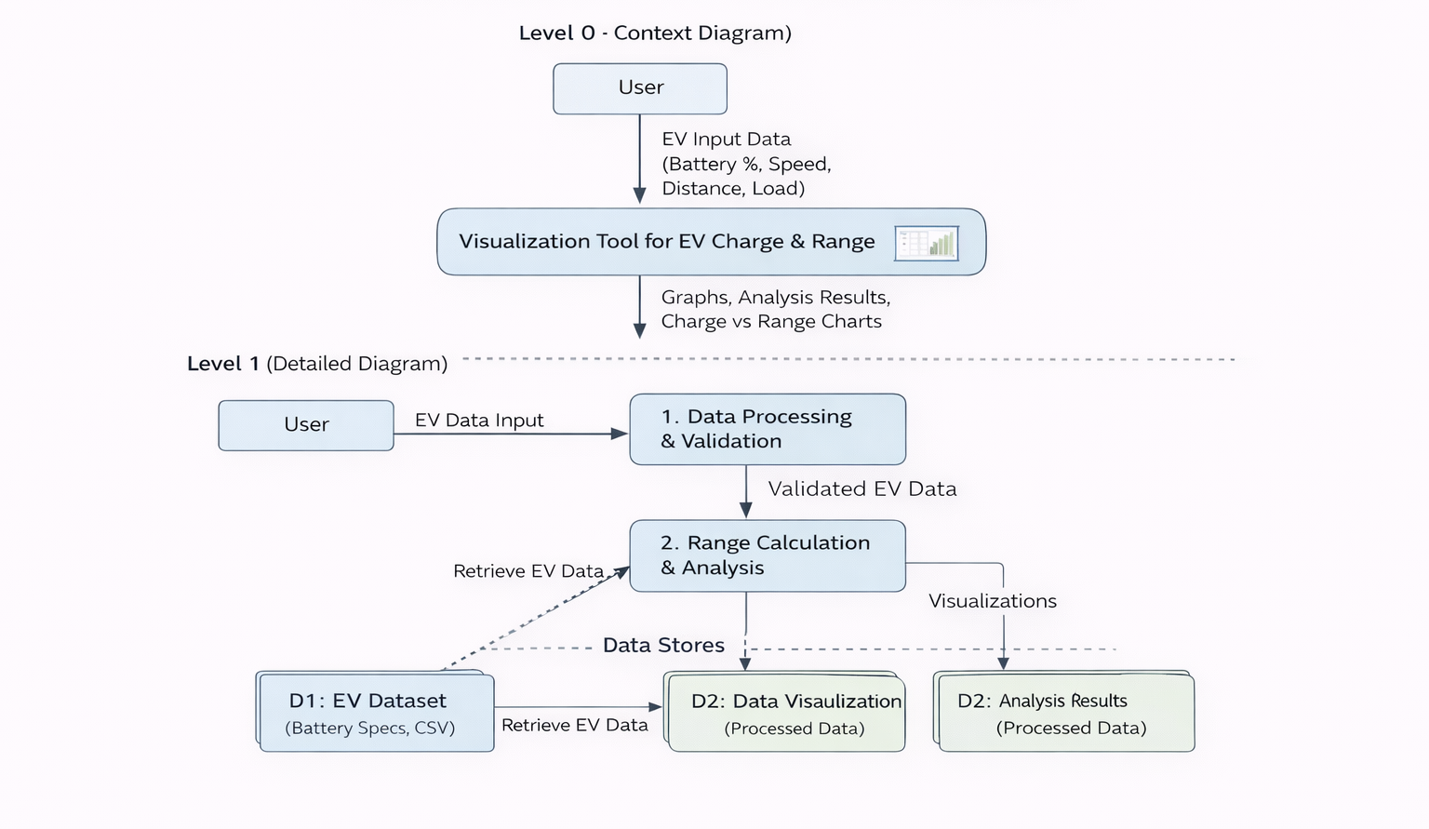

User Stories
Use the below template to list all the user stories for the product.
User Type | Functional Requirement (Epic) | User Story Number | User Story / Task | Acceptance criteria | Priority | Release
Customer (Mobile user) | Data Input | USN-1 | As a user, I can enter EV parameters such as battery percentage, speed, distance, and load. | System accepts valid EV input values and displays no errors. | High | Sprint-1
Customer (Mobile user) | Data Validation | USN-2 | As a user, I want the system to validate my input values before processing. | Invalid inputs show proper error messages. | High | Sprint-1
Customer (Mobile user) | Range Calculation | USN-3 | As a user, I want to calculate the estimated driving range based on battery level and usage conditions. | System displays calculated range correctly. | High | Sprint-1
Customer (Mobile user) | Visualization | USN-4 | As a user, I want to view graphical charts showing Charge vs Range analysis. | Graphs are generated and displayed correctly. | High | Sprint-1
Customer (Mobile user) | Performance Analysis | USN-5 | As a user, I want to analyze battery efficiency under different speeds and loads. | System updates analysis results dynamically. | Medium | Sprint-2
Customer (Mobile user) | Dataset Upload | USN-6 | As a user, I can upload EV dataset files (CSV) for analysis. | System successfully reads and processes CSV file. | Medium | Sprint-2
Customer (Web user) | Dashboard | USN-7 | As a user, I can view all analysis results in a  dashboard format. | Dashboard displays charts and summary metrics. | High | Sprint-1
Administrator | Data Management | USN-8 | As an admin, I can manage EV datasets used in the system. | Admin can add/update/delete datasets. | Medium | Sprint-2
Administrator | System Monitoring | USN-9 | As an admin, I can monitor system performance and usage. | System logs and usage details are accessible. | Low | Sprint-3

